# Task 8: Working with VPNs

Intern Name: Jainam Priteshkumar Shah

Date: 15/08/2025

Internship Provider: Elevate Labs

## 1. Objective

Understand the role of VPNs in protecting privacy and secure communication.

## 2. Tools Used

* **ProtonVPN (Free Tier):** A reputable VPN service with a free client for Windows.
* **Web Browser & IP Checker:** A web browser to test connectivity and an online tool like whatismyipaddress.com to verify my public IP address.

## 3. Procedural Steps

This section details the step-by-step process I followed to set up and test the VPN.

### 3.1. Sign-up and Installation

First, I created a free account on the ProtonVPN website. After signing up, I downloaded the ProtonVPN client for Windows and followed the installation wizard to install it on my computer.

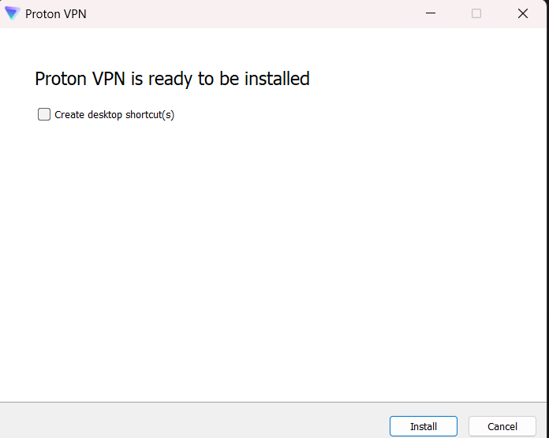

8.1 Proton VPN Installation

### 3.2. Connecting to a VPN Server

I launched the ProtonVPN client and logged in with the credentials I created. The application displayed a map and a list of available countries with free servers. I chose a server in the Netherlands and clicked the "Connect" button. The application quickly established a secure connection.

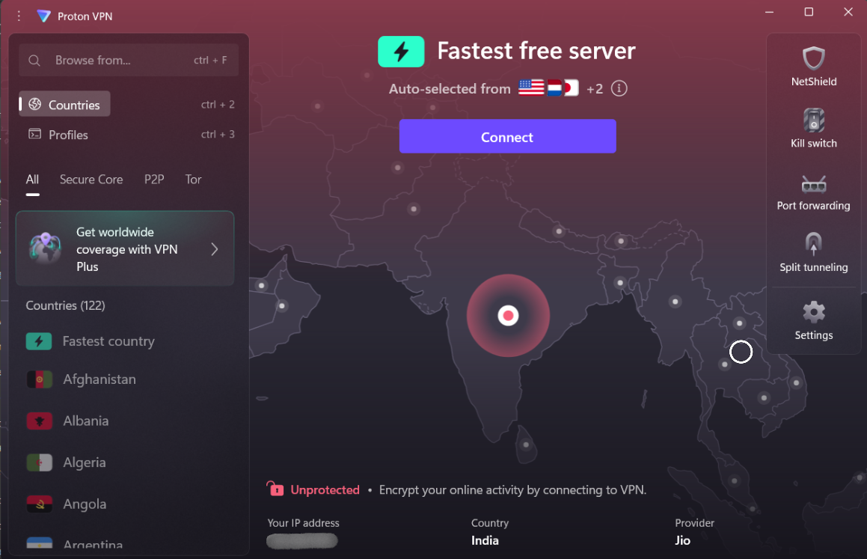

8.2 Proton VPN Home

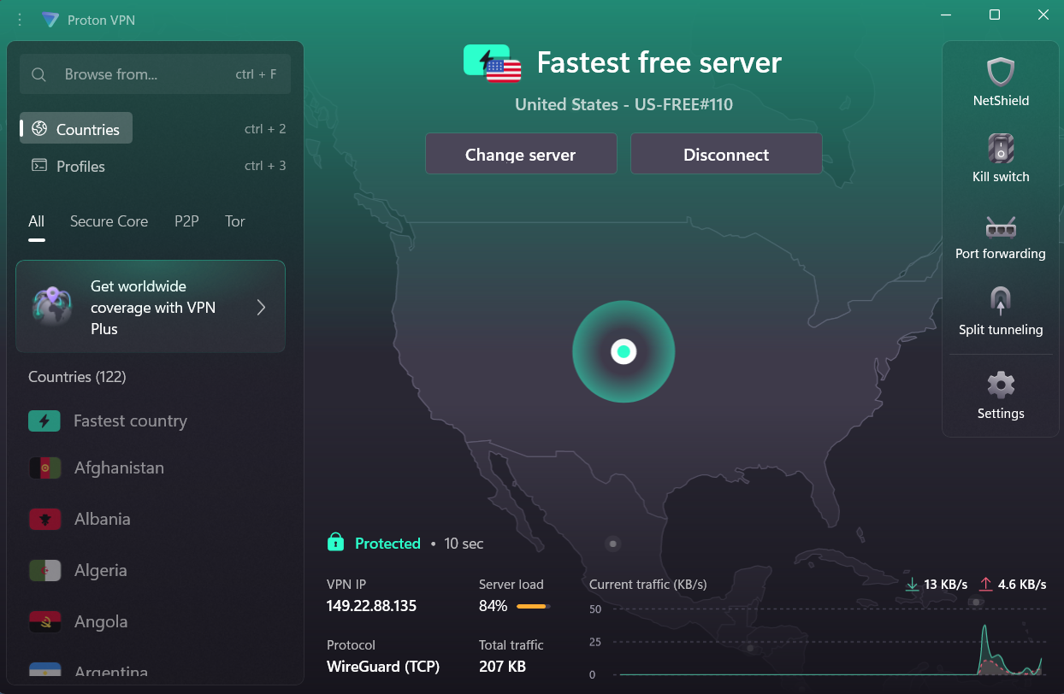

8.3 VPN Connection (US Server)

### 3.3. Verifying the IP Address Change

To confirm that my traffic was being routed through the VPN, I performed a "before and after" test.

1. **Before Connecting:** I visited whatismyipaddress.com and noted my real public IP address and location.
2. **After Connecting:** With the VPN active, I refreshed the same website. The site now displayed the new IP address assigned by the ProtonVPN server in the Netherlands, confirming that my real IP was successfully masked.

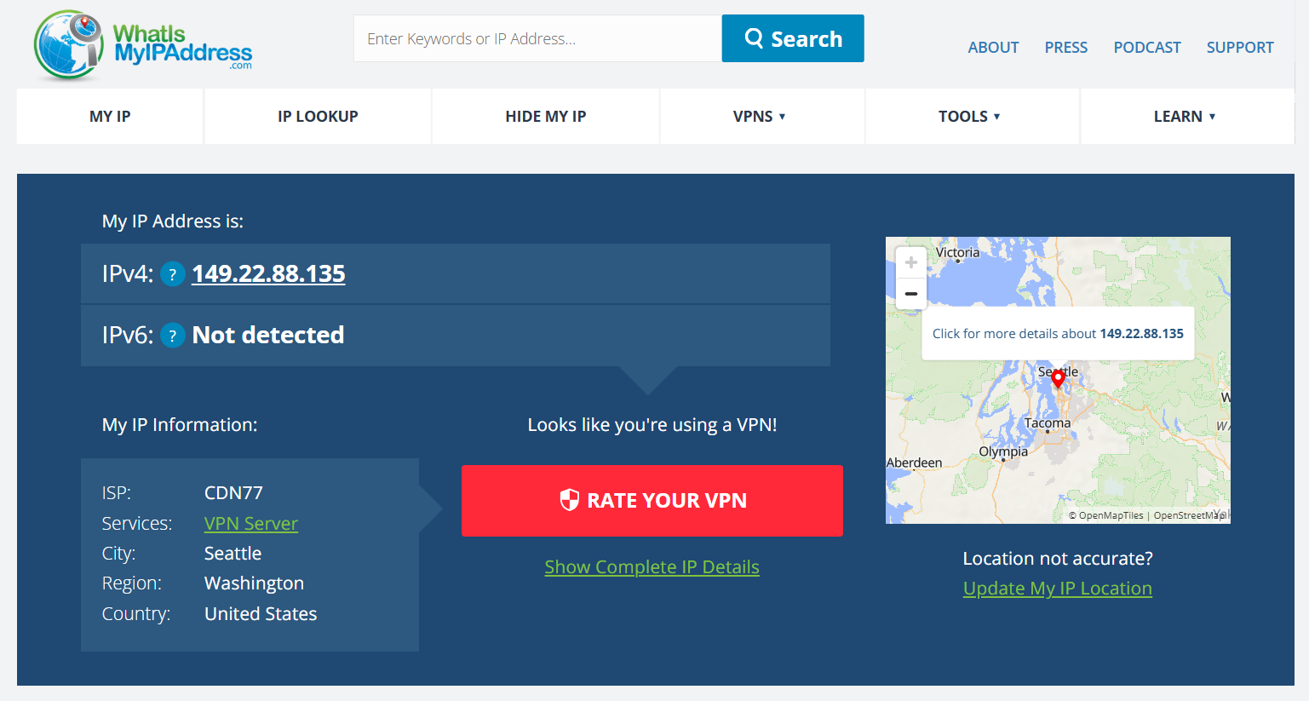

8.4 After connecting VPN Server

### 3.4. Disconnecting and Comparing Performance

After verifying the connection, I browsed a few websites to get a feel for the performance. The speed was slightly slower than my normal connection, which is an expected trade-off for the encryption overhead.

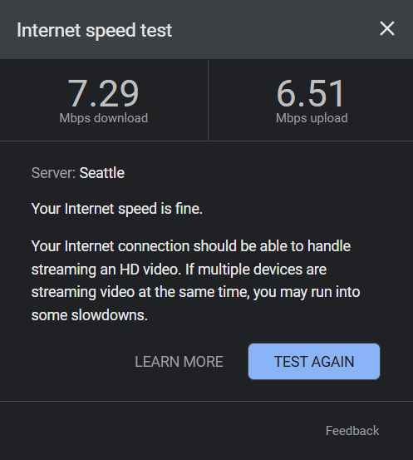 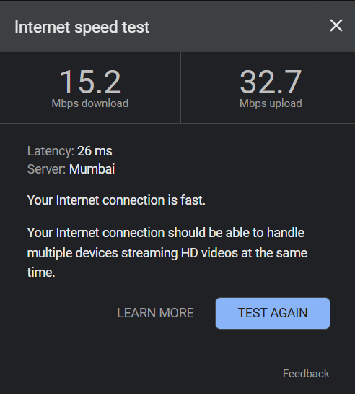

## 4. VPN Benefits and Limitations

Based on my research and this hands-on test, I summarized the key benefits and limitations of using a VPN.

**Benefits:**

* **Privacy:** Hides your real IP address from websites and online services, preventing them from tracking your location.
* **Security:** Encrypts all your internet traffic, creating a secure tunnel. This is especially important on public Wi-Fi, as it prevents eavesdroppers from intercepting your data.
* **Bypassing Geo-restrictions:** Allows you to access content that might be blocked in your geographical region by making it appear as if you are browsing from a different country.

**Limitations:**

* **Reduced Speed:** The process of encrypting and routing your traffic through an extra server can slow down your internet connection.
* **Trust in the VPN Provider:** A VPN doesn't provide perfect anonymity. You are shifting your trust from your Internet Service Provider (ISP) to the VPN provider. It's crucial to choose a reputable VPN with a strict "no-logs" policy.
* **Not a Solution for All Threats:** A VPN does not protect you from malware, viruses, or phishing attacks. It only secures your network traffic.